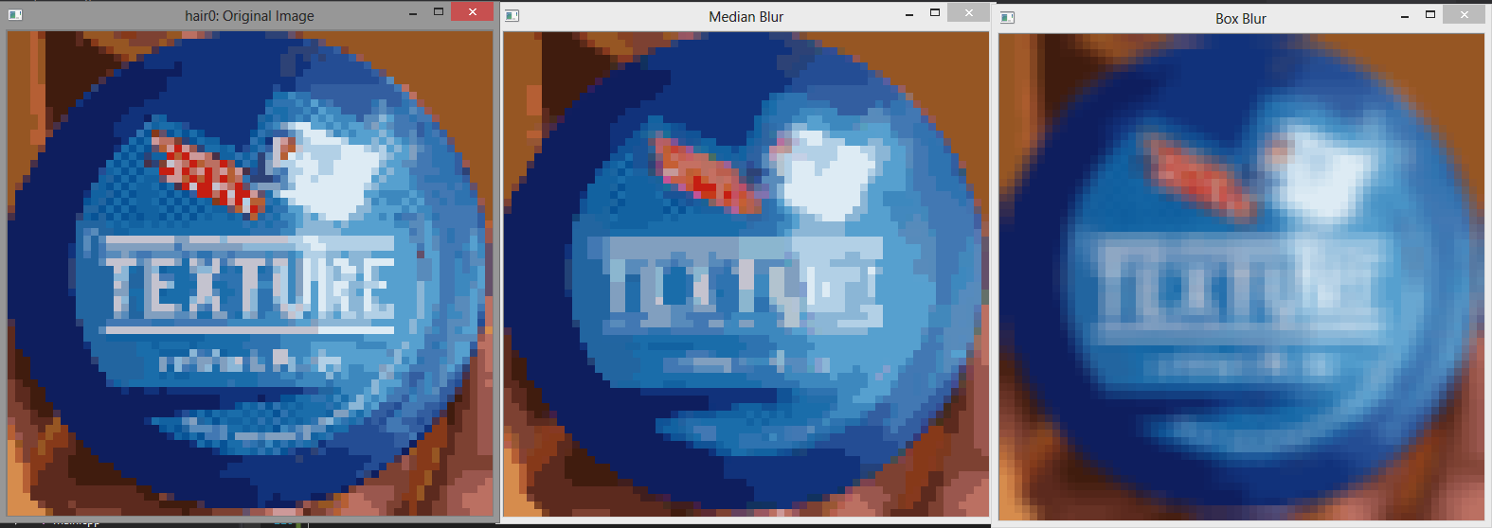

Went back to work on finding the most frequent colours. Explored different blur types that may help smooth anomalous colours. I tried two blurs: Median and Box blur (standard 3x3, equally weighted convolution mask)

For average colours to work, we will need to normalised images so that slight variations in color snap to the same value. By virtue of averages, slight differences should be disregarded as we are looking at the general pixel data.

# Color Snapping

Color snapping an individual pixel has two steps:

1. Convert to HSL
2. Snap the Hue value to an interval segment (of size TBD)
3. Set Saturation and lightness to constant values (so the only difference between pixels is their hue)

For example, after step 3, the following image is generated from the input:



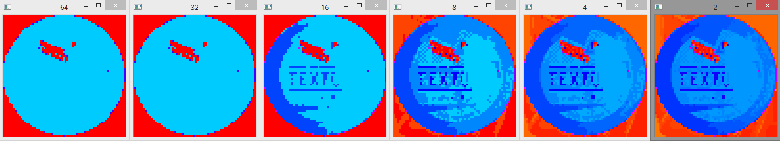

The above images are normalized versions of the input after full normalisation. For the hue snapping, they snaps to segments of size 64, 32, 16, 8, 4, and 2 respectively.

Among them all, a segment size of 16 seems to be, intuitively, a good compromise between detail and basic segmentation.

The following are the results after performing the same operation on a different image of the same subject.

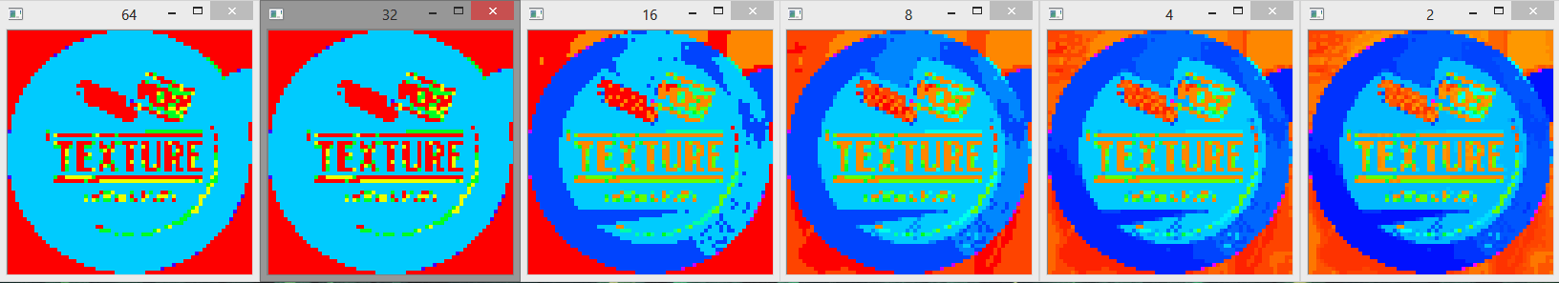

# Median Blur

A median blur of filter size 5x5 is applied to the image after colour-snap has been performed, to reduce anomalies. The following is the result:

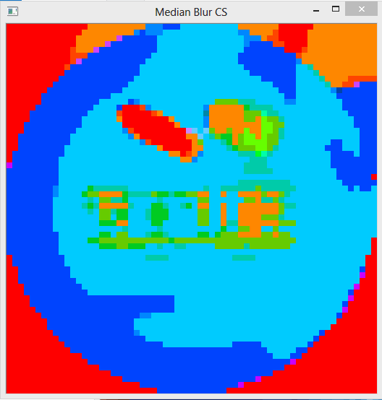

This has successfully reduced the importance of the differing pixels found in the centre of the image.

Now to make sure this works naturally for all test images.